

**MINNESOTA STATE UNIVERSITY, MANKATO**

**DEPARTMENT OF COMPUTER INFORMATION SCIENCE**

**COMPUTER SCIENCE PROGRAM**

**REQUIREMENTS ANALYSIS DOCUMENT**

**THE BETTER BUSINESS BUREAU TEAM**

**Clients:**

Ryan Sharp

BBB Twin Cities

Eli Johnson

IABBB

Rubens Pessanha

IABBB

**THE BETTER BUSINESS BROTHERS**

Tebibu Kebede

Team Lead

Pedro Gomes do Nascimento

Data Engineer

Justin Engels

Database Engineer

Ali Rashid

Data Pipeline Engineer

Mohamed Farag

Data Pipeline Engineer

**FACULTY COACH**

Ryne Leytem

# Table of Contents

Title Page….............................................................................................................................................1

Table of Contents 2

1 | Project Overview 2

• 1.2 Importance of Up-to-Date Data 2

1.3 SCOPE 2

2 | Project Goals and Objectives 3

• 2.3 Objectives 3

3 | Analysis of Stakeholders 3

3.1 Key Stakeholders 3

3.2 Roles and Responsibilities 3

4 | Functional Requirements 3

• 4.2 Data Science Techniques 4

• 4.3 Automation of Data Collection and Changes to the Database 4

5 | Non-Functional Requirements 4

o 5.2 Performance/Scalability Requirements 4

6 | Constraints and Assumptions 4

• 6.2 Assumptions during analysis phase 4

7 | Client Approval 5

# 1 | Project Overview

* **1.1 Data Company**

Better Business Bureau, a data-driven company, relies on accurate and current business information to earn user trust. Our enhancements focus on advanced data management and validation techniques for efficient introduction of new business entries and maintaining ongoing data quality.

#### **1.2 Importance of Up-to-Date Data**

This project includes mechanisms for adding new business entries and maintaining high data quality through regular validation against external sources, aligning with BBB's goals of enhancing data precision and integrity.

## 1.3 SCOPE

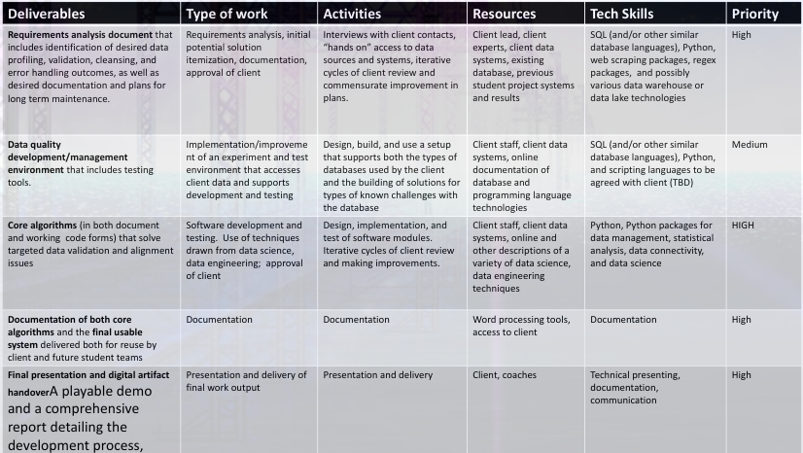

Figure 1: Key deliverables for this project.

# 2 | Project Goals and Objectives

* **2.2 Primary Goal**

Our goal is to improve the current data management system by implementing machine learning for predictive accuracy and introducing automated processes for new business entries and ongoing data quality assurance.

#### **2.3 Objectives**

**Machine Learning Implementation**: Utilizing logistic regression to predict data accuracy.

**New Business Entry**: Automated processing and validation of new business entries.

**Data Quality Assurance**: Regular validation and update of business information to maintain high data quality and integrity

# 3 | Analysis of Stakeholders

## 3.1 Key Stakeholders

In this section, we identify and describe the key stakeholders involved in the BBB Data Management Project.

* Project Team: The internal project team is responsible for the development, implementation, improvement, and management of the data management system. Roles include data engineer, database engineer, data pipeline developers, and project managers.
* Ryan Sharp: Ryan Sharp, representing BBB, is the primary client and the key decision-maker for the project.
* Eli Johnson: Eli Johnson is a technical and organizational specialist from the IABBB (Internal Association of BBB), ensuring the project aligns with their standards and provides necessary resources and support.

## 3.2 Roles and Responsibilities

In this section, we outline the roles and responsibilities of the key stakeholders in the BBB Data Management Project:

* Project Team: The project team is responsible for developing, implementing, and improving the data management system. Data engineers gather data from diverse sources, while Database engineers ensure data quality. Project lead oversees the project's progress.
* Ryan Sharp: Ryan Sharp defines project objectives, provides high-level guidance, and makes strategic decisions. He also ensures the project aligns with BBB's goals and objectives.
* Eli Johnson: Eli Johnson contributes technical expertise, organizational support, and allocates resources as needed to support the project's success. He ensures that the project aligns with IAIBB standards.

# 4 | Functional Requirements

We recommend non-technical workers to read the “Overview” and not the “Technical Description”.

* **4.1 Data Management System**

**New Business Entry**: System should support the easy addition of new business entries, with checks for duplicates and validation against external sources.

#### **4.2 Data Science Techniques**

Enhance with real-time data validation and anomaly detection, focusing on maintaining a high level of accuracy and reliability.

#### **4.3 Automation of Data Collection and Changes to the Database**

**Automated Validation**: Incorporate automated identification and validation against external data sources like the Secretary of State's database and Google Places API.

# 5 | Non-Functional Requirements

Needs that will help ensure project success but will not be mission critical to the project.

* **5.1 Data Accuracy, Reliability, and Efficiency**

**Data Validation Accuracy**: Strive for a high percentage of accuracy in automated data validation.

#### **5.2 Performance/Scalability Requirements**

Consider the impact of new features on system performance and scalability.

# 6 | Constraints and Assumptions

* **6.1 Budget and Time Limitations**

Ensure the new enhancements align with the budget and project timeline.

#### **6.2 Assumptions during analysis phase**

The project team assumes the availability and accessibility of external data sources for validation.

# 7 | Client Approval

|  |  |  |  |  |
| --- | --- | --- | --- | --- |
| Ryan Sharp |  |  |  |  |
| **Primary Client** |  | **Signature** |  | **Date** |
| Eli Johnson |  |  |  |  |
| **Technical Specialist** |  | **Signature** |  | **Date** |
| Rubens Pessanha |  |  |  |  |
| **Technical Specialist** |  | **Signature** |  | **Date** |